Step 0 - Install IntelliJ
Click on this link and install - https://www.jetbrains.com/idea/download/?section=mac

Step 1 - Prompt
You are a senior AI engineer AND a teacher.

Your task is to generate a SINGLE, SELF-CONTAINED HTML FILE
that runs entirely in the browser and helps users learn
how “fine-tuning-like behavior” works in Large Language Models
using inference controls (temperature, top-p, top-k, instructions).

This file must be runnable by simply opening it in a browser.
No backend. No frameworks. No external libraries.

========================
ABSOLUTE RULES
========================

1. Output ONLY the final HTML file
2. Use plain HTML, CSS, and vanilla JavaScript
3. All CSS must be inside <style>
4. All JavaScript must be inside <script>
5. No React, no Vue, no Tailwind, no CDN
6. UI must NEVER break even if API calls fail
7. Errors must be explained in simple human language
8. The result should work for beginners AND teach correct mental models

========================
GOAL OF THE PLAYGROUND
========================

When a student opens the file, they should:
- Enter an LLM API key (Gemini-style, but logic should be clear and adaptable)
- Select a model from a list
- Select a “Response Style” (preset behavior)
- See hyperparameters and instructions auto-populate
- Modify them manually if desired
- Run a prompt and see how output changes
- Understand the difference between:
- Prompt engineering
- Inference tuning
- Real fine-tuning

This is a LEARNING TOOL, not a production app.

========================
SECTION 1: API KEY SETUP
========================

Create a section titled:
🔐 API Key Setup

Features:
- Text input for API key
- “Validate API Key” button
- Validation should:
- Make a lightweight API call (e.g., list models)
- If successful → show green “API Key Valid”
- If failed → show red error with readable explanation

Important:
- Listing models may succeed even when generation fails
- The UI should explain this clearly to the user
- Never crash if validation fails
- Disable “Run Prompt” until key is validated

========================
SECTION 2: MODEL DISCOVERY & SELECTION
========================

Create a section:
🧠 Model Selection

Behavior:
- After API key validation:
- Fetch available models
- Filter to text / generative models only
- Populate a dropdown

Critical learning:
- Not all listed models are safe for text generation
- Some may fail due to quota, permissions, or model type

Engineering requirement:
- When generating text:
- Attempt the selected model first
- If it fails, automatically fall back to safe defaults
(example: fast, general-purpose text models)
- Never expose raw stack traces

Show in UI:
- Which model was actually used
- If fallback occurred, explain why in simple language

========================
SECTION 3: RESPONSE STYLE PRESETS
========================

Create a section:
🎭 Response Style

Provide radio-button presets:

1. Innovative Thinker
2. Factual & Precise
3. Funny Kid (8–10 years old)
4. Informed Product Manager
5. No-Nonsense Fact Teller
6. Custom

Each preset MUST auto-populate ALL of the following:
- Temperature
- Top-P
- Top-K
- System / Instruction Prompt

VERY IMPORTANT:
- When a student clicks a preset:
- Sliders update immediately
- Instruction text updates immediately
- On page load:
- A default preset is selected
- Its instructions are already filled

Students must still be able to:
- Edit instructions manually
- Override parameters even after selecting a preset

========================
SECTION 4: HYPERPARAMETER CONTROLS
========================

Create a section:
🎛️ Model Controls (Inference Tuning)

Include:
- Temperature (0.0 – 1.5)
- Top-P (0.0 – 1.0)
- Top-K (1 – 100)
- Max Output Tokens (50 – 2048)

For EACH control:
- Slider + numeric input
- Slider and number must stay in sync
- Inline explanation in plain English

Example explanations:
- “Temperature controls creativity”
- “Top-P controls how many probable words are considered”

========================
SECTION 5: INSTRUCTION & PROMPT
========================

Create:
🧠 Instruction & Prompt

Include:
- “System / Instruction Prompt” textarea
(behavior steering)
- “User Prompt” textarea
(the actual question)
- “Run Prompt” button

Rules:
- System + User prompts must be sent explicitly
- Instructions must meaningfully affect output
- Empty user prompts should be handled gracefully

========================
SECTION 6: OUTPUT & FEEDBACK
========================

Create:
📤 Model Output

Include:
- Scrollable output area
- Preserve formatting
- Show:
- Approx latency
- Model used
- If an error occurs:
- Explain what likely went wrong
- Suggest what to try next (change model, check quota, etc.)

The UI must never become unusable.

========================
SECTION 7: NON-BREAKING DESIGN
========================

The app MUST:
- Never throw uncaught JavaScript errors
- Gracefully handle:
- Invalid API key
- Quota exceeded
- Unsupported model
- Network failures
- Always keep the interface responsive

Fallback logic is REQUIRED.

========================
SECTION 8: EDUCATIONAL FOOTER
========================

At the bottom, add:

📘 Understanding Fine-Tuning (Simple Explanation)

Explain in very simple language with examples:

- What is Temperature?
- What are Top-P and Top-K?
- Why this playground is NOT real fine-tuning
- What real fine-tuning actually means
- Difference between:
- Prompt engineering
- Inference tuning
- Fine-tuning
- What API keys are and why they should be protected

Tone:
- Beginner-friendly
- No jargon without explanation
- Analogies encouraged

========================
FINAL OUTPUT REQUIREMENTS
========================

- Output ONLY valid HTML
- No markdown
- No explanations outside the HTML
- File must be copy-paste runnable
- Should work when opened locally in a browser

This playground should make students say:
“Oh — now I actually understand what fine-tuning means.”

Generate the complete HTML file now.

Step 2 - Get your API Key
Go to the link - https://aistudio.google.com/app/u/2/api-keys?pli=1
- Click on create an API key
- Copy the API Key
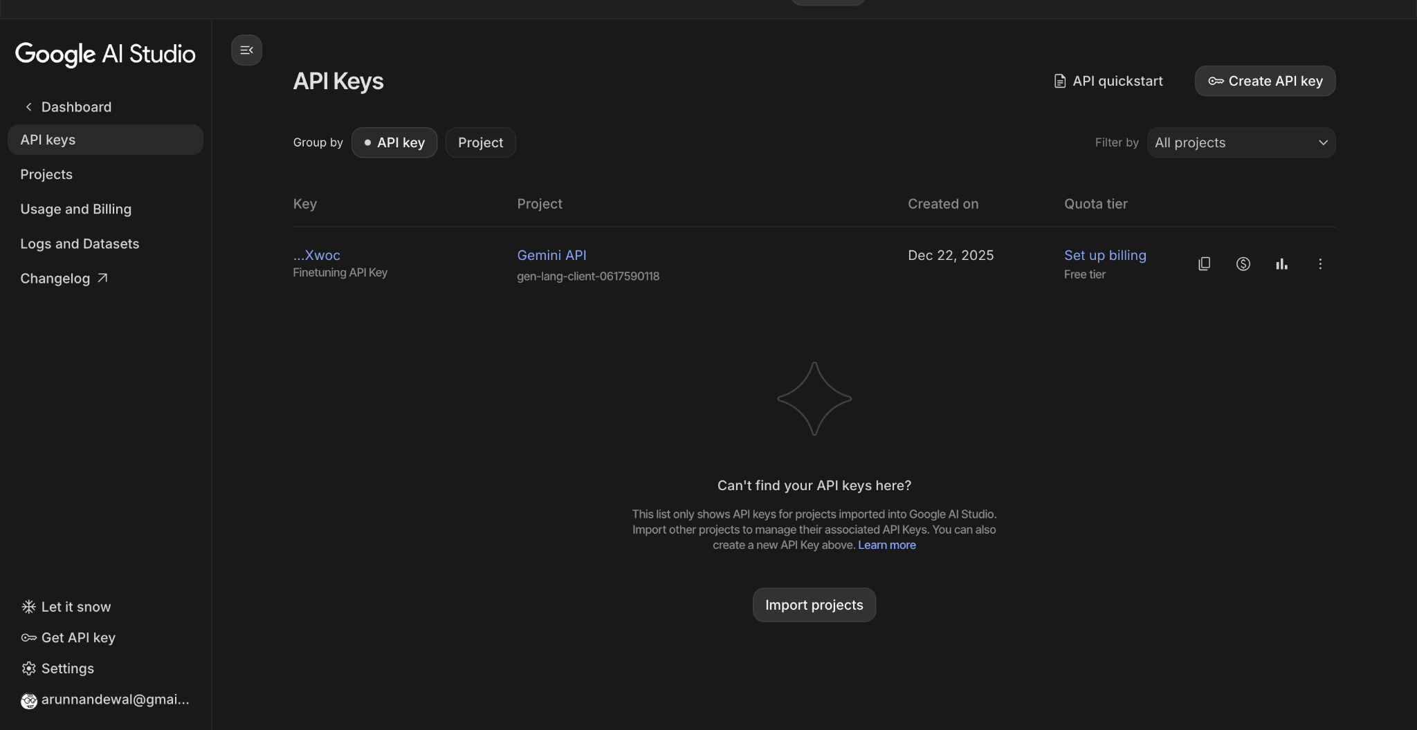

Step 3 - Run the HTML file
- Open the html file in browser
- Copy the API key - hit validate the API key
- Select the model - Gemini-2.5-flash-lite model
- Select the mode - Innovative thinker / Funny Kid or one of them
- Enter the user prompt
- Tweak and play with the Hyperparameters
